Coin Change Problem

CODE:

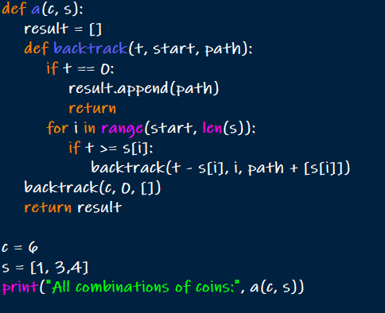

OUTPUT:



Knapsack Problem

CODE:

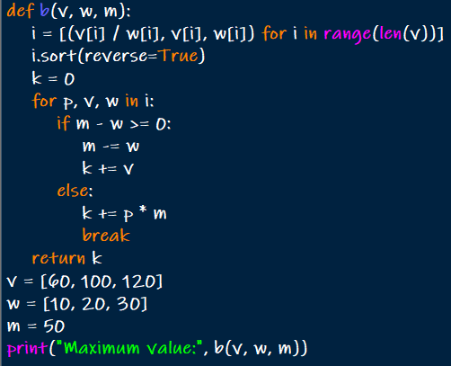

OUTPUT:



Job Sequencing with Deadlines

CODE:

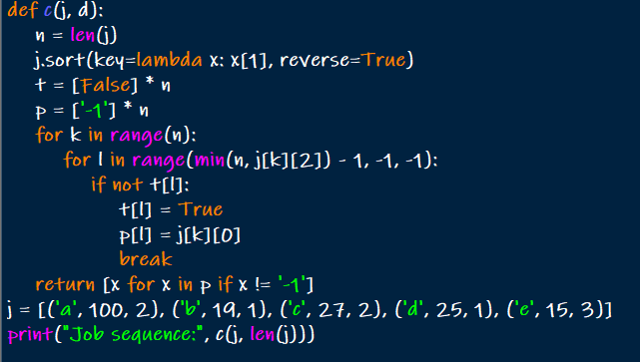

OUTPUT:



Single Source Shortest Paths: Dijkstra's Algorithm

CODE:

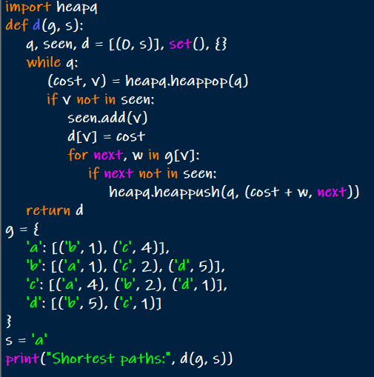

OUTPUT:



Optimal Tree Problem: Huffman Trees and Codes

CODE:

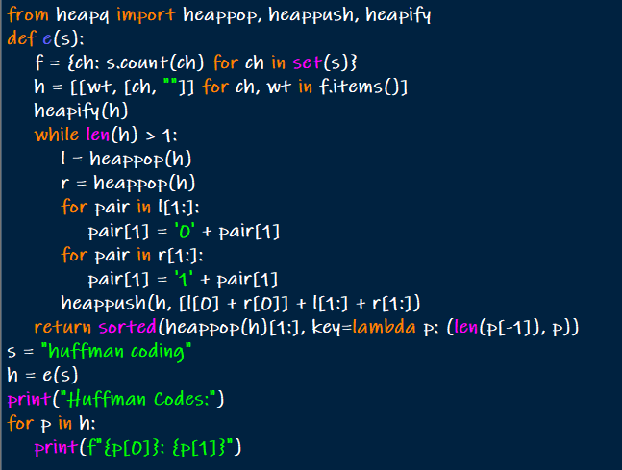

OUTPUT:

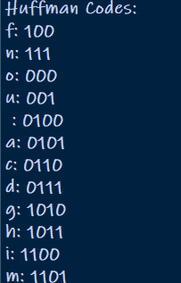

Container Loading

CODE:

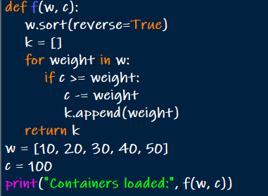

OUTPUT:



Kruskal's Algorithms

CODE:

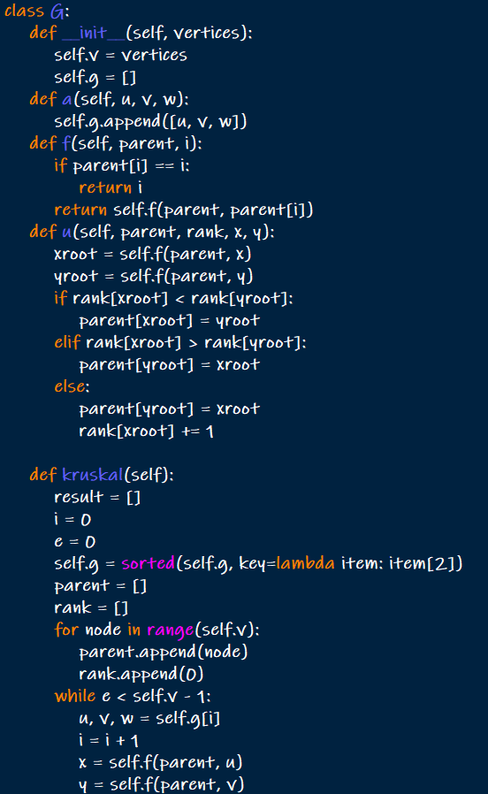

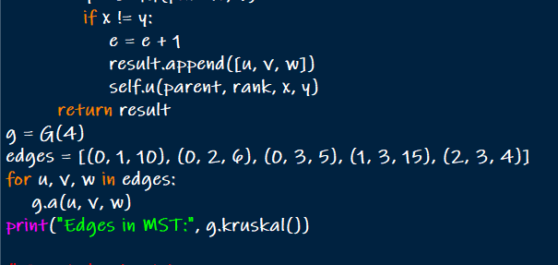

OUTPUT:



Prims Algorithm

CODE:

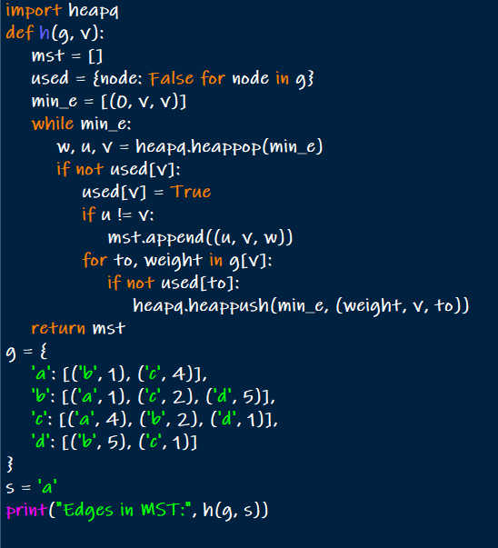

OUTPUT:



Boruvka's Algorithm

CODE:

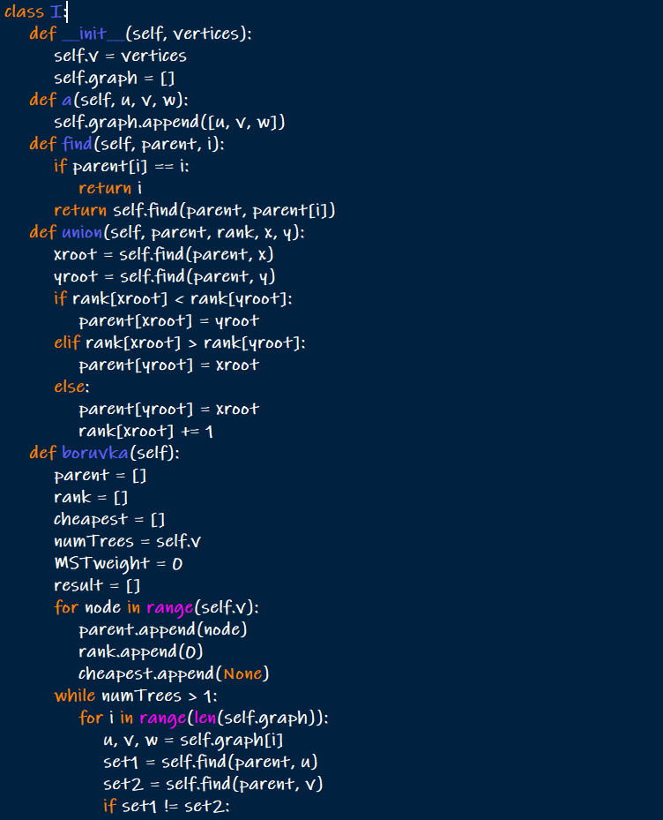

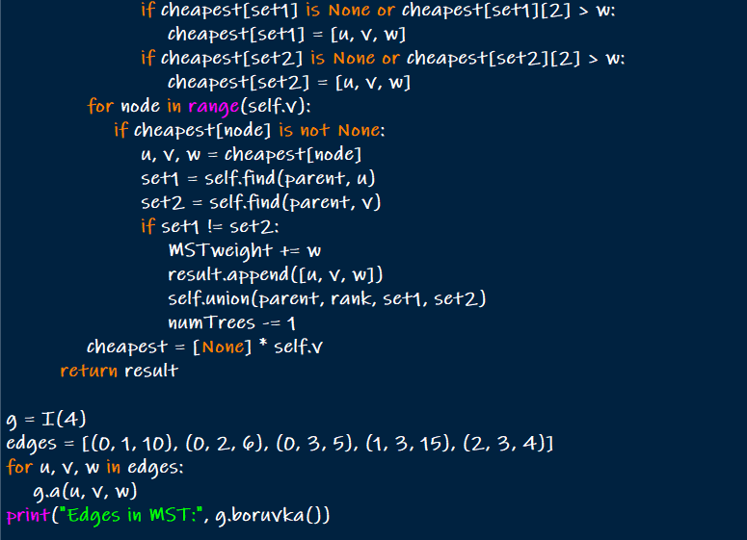

OUTPUT:

